TASK 1

class item{  
 String title,author;  
 String year;  
  
 public item() {  
 }  
  
 public item(String title, String author, String year) {  
 this.title = title;  
 this.author = author;  
 this.year = year;  
 }  
  
 public String tostring(){  
 return "Book title is "+title+"\nAuthor is "+author+"\nyear is "+year;  
 }  
}  
class book extends item{  
 String publisher;  
 String isbn;  
  
 public book() {  
 }  
  
 public book(String title, String author, String year, String publisher, String isbn) {  
 super(title, author, year);  
 System.*out*.println("\nThis Item is Book");  
 this.publisher = publisher;  
 this.isbn = isbn;  
 }  
  
 public String tostring(){  
  
 return super.tostring()+"Publisher is "+publisher+"\nISBN no is "+isbn;  
 }  
}  
class magazine extends item{  
 String publisher;  
 String issueNumber;  
  
 public magazine() {  
 }  
  
 public magazine(String title, String author, String year, String publisher, String issueNumber) {  
 super(title, author, year);  
 System.*out*.println("\nThis Item is Magazine");  
 this.publisher = publisher;  
 this.issueNumber = issueNumber;  
 }  
  
 public String tostring(){  
 return super.tostring()+"Publisher is "+publisher+"\nIssue Number is"+issueNumber;  
 }  
}  
class DVD extends item{  
 String director,length;  
  
 public DVD(String title, String author, String year, String director, String length) {  
 super(title, author, year);  
 System.*out*.println("\nThis Item is DVD");  
 this.director = director;  
 this.length = length;  
 }  
  
 public DVD() {  
 }  
  
 public String tostring(){  
 return super.tostring()+"Director is "+director+"\nLength is"+length;  
 }  
}  
public class Main {  
 public static void main(String[] args) {  
 item b1 = new book("opp in java","unknown", "2003","Denial","22k-4079");  
 System.*out*.println(b1.tostring());  
 item m1 = new magazine("Raftar","Bhadur","2017","Zee","S8-4577");  
 System.*out*.println(m1.tostring());  
 item d1 = new DVD("Zoom","John","2020","Wick","2:30h");  
 System.*out*.println(d1.tostring());  
  
  
 }  
}

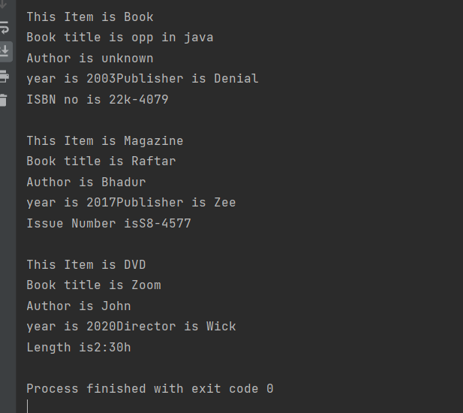

TASK 2

import java.security.spec.RSAOtherPrimeInfo;  
  
class person{  
 public String name,email,phNo;  
  
 public person() {  
 }  
  
 public person(String name, String email, String phNo) {  
 this.name = name;  
 this.email = email;  
 this.phNo = phNo;  
 }  
  
 public String tostring(){  
 return "\nName is "+name+"\nEmail is "+email+"\nPhone No is"+phNo;  
 }  
  
}  
class student extends person{  
 public String studentId,major;  
  
 public student() {  
 }  
 public student(String name, String email, String phNo, String studentId, String major) {  
 super(name, email, phNo);  
 this.studentId = studentId;  
 this.major = major;  
 }  
 public String getGPA(){  
 return major;  
 }  
 public String tostring(){  
 return super.tostring()+"\nStudent Id is"+studentId+"\nMajor is "+major;  
 }  
}  
class faculty extends person{  
 public String facultyId,department;  
  
 public faculty() {  
 }  
  
 public faculty(String name, String email, String phNo, String facultyId, String department) {  
 super(name, email, phNo);  
 this.facultyId = facultyId;  
 this.department=department;  
 }  
 public String getRank(){  
 return department;  
 }  
 public String tostring(){  
 return super.tostring()+"\nFaculty Id is "+facultyId+"\nDepartment is"+department;  
 }  
}  
class staff extends person{  
 public String staffId,jobTitle;  
 private int salary;  
  
 public staff() {  
 }  
 public staff(String name, String email, String phNo, String staffId, String jobTitle, int salary) {  
 super(name, email, phNo);  
 this.staffId = staffId;  
 this.jobTitle = jobTitle;  
 this.salary = salary;  
 }  
 public String tostring(){  
 return super.tostring()+"\nStaff Id is "+staffId+"\nJob is "+jobTitle;  
 }  
  
 public int getSalary(){  
 return salary;  
 }  
}  
public class Main {  
 public static void main(String[] args) {  
 System.out.println("Hello world!");  
  
 person s1 = new student("Partham", "parthamkumar420@gmail.com", "0336-xxxxxxx", "22k-4079", "oops");  
 person f1 = new faculty("kumar", "kumar123@gmail.com", "0300-xxxxxxx", "Sn-0202", "Finance");  
 person st1 = new staff("John", "John432@gmail.com", "0328-xxxxxxx", "SF-8004", "Helper", 500);  
 System.out.println(s1.tostring());  
 System.out.println(f1.tostring());  
 System.out.println(st1.tostring());  
  
}

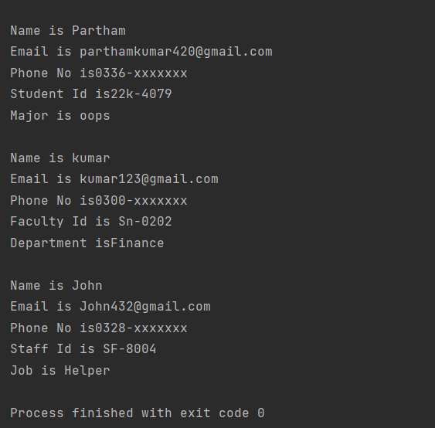

Task 3

class robot{  
 int x=0,y=0;  
  
 public robot() {  
 }  
  
 public robot(int x, int y) {  
 this.x = x;  
 this.y = y;  
 }  
 public void display(){  
 System.*out*.println("Initial position is "+x+" "+y);  
 }  
  
}  
class movingRobot extends robot{  
 // public String direction;  
 // public int unit;  
 public movingRobot() {  
 }  
 public movingRobot(int x, int y) {  
 super(x, y);  
 }  
 public void moveRobot(int unit, String direction){  
 if (direction=="N"||direction=="n"){  
 super.y=super.y+unit;  
 }  
 if (direction=="S"||direction=="s"){  
 super.y=super.y-unit;  
 }  
 if (direction=="E"||direction=="e"){  
 super.x=super.x+unit;  
 }  
 if (direction=="W"||direction=="w"){  
 super.x=super.x-unit;  
 }  
 }  
 public void display(){  
 System.*out*.println("Current position is "+super.x +" "+super.y);  
 }  
}  
public class Main {  
 public static void main(String[] args) {System.*out*.println("Hello world!");  
 robot r1 = new robot(100,100);  
 movingRobot m1 = new movingRobot(100,100);  
 m1.moveRobot(5,"n");  
 r1.display();  
 m1.display();  
 m1.moveRobot(10,"W");  
 m1.display();  
}}

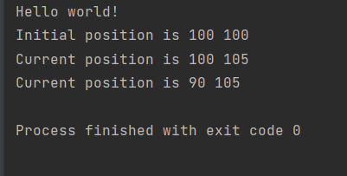

Task 4

class Accounts{  
 public float balance;  
 public void debit(int amount){  
 balance= balance-amount;  
 }  
 public Accounts() {  
 }  
 public void credit(int amount){  
 balance = balance+amount;  
 }  
 public void getbalace(){  
 System.*out*.println(balance);  
 }  
}  
class savingAccount extends Accounts{  
 public float timeSpan;  
 public float interestRate;  
 public float interest;  
 public savingAccount() {  
 }  
 public savingAccount(float timeSpan, float interestRate) {  
 this.timeSpan = timeSpan;  
 this.interestRate=interestRate;  
 }  
 public void timespan(){  
 System.*out*.println("hello");  
 }  
 public void interestRa(){  
 interest = balance\*timeSpan\*(interestRate/100);  
 }  
 public void credit(){  
 super.balance=super.balance+interest;  
 }  
}  
class checkingAccount extends Accounts{  
}  
public class Main {  
 public static void main(String[] args) {  
 System.*out*.println("Hello world!");  
 savingAccount A1 =new savingAccount(2,5);  
 A1.credit(1000);  
 A1.debit(50);  
 A1.interestRa();  
 A1.credit();  
 System.*out*.println(A1.interest);  
 A1.getbalace();  
 }  
}

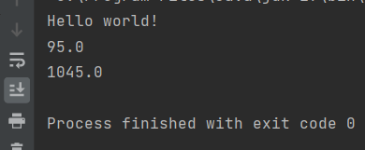

TASK 5

import java.util.Arrays;  
import java.util.Comparator;  
class sorting{  
 public void sort(Integer[] array){  
 Arrays.*sort*(array);  
 }  
 public void sort(String[] array){  
 Arrays.*sort*(array,Comparator.*reverseOrder*());  
 }  
 public void sort(Integer[] array, boolean choice){  
 if (choice == true)  
 Arrays.*sort*(array);  
 else Arrays.*sort*(array,Comparator.*reverseOrder*());  
 }  
 public void sort(String[] array, boolean choice){  
 if (choice == true)  
 Arrays.*sort*(array);  
 else Arrays.*sort*(array,Comparator.*reverseOrder*());  
 }  
}  
public class Main {  
 public static void main(String[] args) {  
 System.*out*.println("Hello world!");  
 sorting s1 = new sorting();  
  
 Integer a[] ={4,7,2,3,5,6};  
 String s[] ={"apple","mango","banana","melon","kiwi"};  
 //Sorting in Ascending order  
 System.*out*.println("Sorting in Ascending order");  
 s1.sort(a);  
 System.*out*.println(a);  
 for (int i =0;i< a.length;i++) {  
 System.*out*.printf((a[i])+" ");  
 }  
 //Sorting in Descending Order  
 System.*out*.println("\nSorting in Descending Order");  
 s1.sort(a,false);  
 for (int i =0;i< a.length;i++) {  
 System.*out*.printf((a[i])+" ");  
 }  
 //Sorting of string in Ascending Order  
 System.*out*.println("\nSorting of string in Ascending Order");  
 s1.sort(s);  
 for (int i=0;i< s.length;i++){  
 System.*out*.println(s[i]);  
 }  
 //Sorting of String in Descending order  
 System.*out*.println("\nSorting of String in Descending order");  
 s1.sort(s,false);  
 for (int i=0;i< s.length;i++){  
 System.*out*.println(s[i]);  
 }  
 }  
 }

